**Worksheet-1.3**

**Student Name:-** Pushpraj Roy **UID:-** 20BCS9866

**Branch:-** BE- CSE **Section/Group:-** WM_617 “A”

**Subjetct Code:-** 20CSP-314 **Semester:-** 5th

**Subject Name:-** Competitive Coding Lab

# Question 1-

1. **Aim:** Find Merge point of two Linked Lists.

Link- [https://www.hackerrank.com/challenges/find-the-merge-point-of-two-joinedlinked-lists/problem](https://www.hackerrank.com/challenges/find-the-merge-point-of-two-joined-linked-lists/problem)

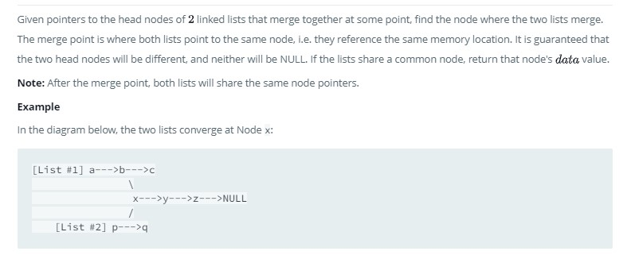

1. **Input Code-**

#include <bits/stdc++.h> using namespace std;

class SinglyLinkedListNode {

public:

int data;

SinglyLinkedListNode *next;

SinglyLinkedListNode(int node_data) {

this->data = node_data;

this->next = nullptr;

}

};

class SinglyLinkedList { public:

SinglyLinkedListNode *head;

SinglyLinkedListNode *tail;

SinglyLinkedList() { this->head = nullptr; this->tail = nullptr;

}

void insert_node(int node_data) {

SinglyLinkedListNode* node = new SinglyLinkedListNode(node_data);

if (!this->head) { this->head = node;

} else {

this->tail->next = node;

}

this->tail = node;

}

};

void print_singly_linked_list(SinglyLinkedListNode* node, string sep, ofstream& fout) { while (node) { fout << node->data;

node = node->next;

if (node) {

fout << sep;

}

}

}

void free_singly_linked_list(SinglyLinkedListNode* node) { while (node) {

SinglyLinkedListNode* temp = node;

node = node->next;

free(temp);

}

}

// Complete the findMergeNode function below.

/*

* For your reference:

*

* SinglyLinkedListNode {
* int data;
* SinglyLinkedListNode* next;
* };
* */

int findMergeNode(SinglyLinkedListNode* head1, SinglyLinkedListNode* head2

) {

while (head1 != NULL) {

SinglyLinkedListNode* temp = head2; while (temp != NULL) { if(head1 == temp){

return temp->data;

}

temp = temp->next;

}

head1 = head1->next;

}

return 0;

}

int main()

{

ofstream fout(getenv("OUTPUT_PATH"));

int tests; cin >> tests;

cin.ignore(numeric_limits<streamsize>::max(), '\n');

for (int tests_itr = 0; tests_itr < tests; tests_itr++) { int index; cin >> index;

cin.ignore(numeric_limits<streamsize>::max(), '\n');

SinglyLinkedList* llist1 = new SinglyLinkedList();

int llist1_count; cin >> llist1_count;

cin.ignore(numeric_limits<streamsize>::max(), '\n');

for (int i = 0; i < llist1_count; i++) {

int llist1_item; cin >> llist1_item;

cin.ignore(numeric_limits<streamsize>::max(), '\n');

llist1->insert_node(llist1_item);

}

SinglyLinkedList* llist2 = new SinglyLinkedList();

int llist2_count; cin >> llist2_count;

cin.ignore(numeric_limits<streamsize>::max(), '\n'); for (int i = 0; i < llist2_count; i++) {

int llist2_item; cin >> llist2_item;

cin.ignore(numeric_limits<streamsize>::max(), '\n');

llist2->insert_node(llist2_item);

}

SinglyLinkedListNode* ptr1 = llist1->head;

SinglyLinkedListNode* ptr2 = llist2->head;

for (int i = 0; i < llist1_count; i++) {

if (i < index) {

ptr1 = ptr1->next;

}

}

for (int i = 0; i < llist2_count; i++) { if (i != llist2_count-1) {

ptr2 = ptr2->next;

}

}

ptr2->next = ptr1;

int result = findMergeNode(llist1->head, llist2->head);

fout << result << "\n";

}

fout.close();

return 0;

}

**3.Output-**

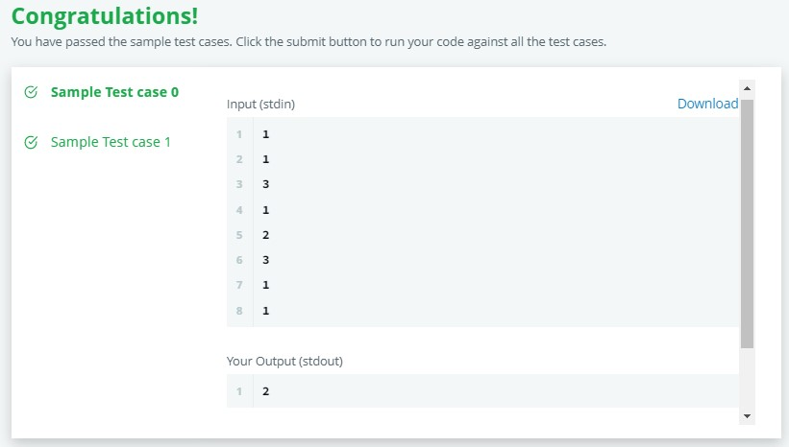

# Question 2-

1. **Aim:** Insert a node into a sorted doubly linked list.

**Link-** [**https://www.hackerrank.com/challenges/insert-a-node-into-a-sorteddoubly-linked-list/problem?isFullScreen=false**](https://www.hackerrank.com/challenges/insert-a-node-into-a-sorted-doubly-linked-list/problem?isFullScreen=false)

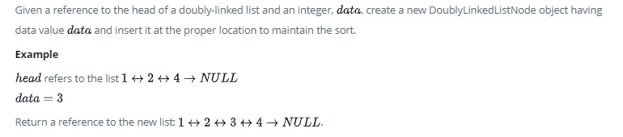

1. **Input Code-**

#include <bits/stdc++.h> using namespace std; class DoublyLinkedListNode { public:

int data;

DoublyLinkedListNode *next;

DoublyLinkedListNode *prev;

DoublyLinkedListNode(int node_data) {

this->data = node_data; this->next = nullptr;

this->prev = nullptr;

}

};

class DoublyLinkedList { public:

DoublyLinkedListNode *head;

DoublyLinkedListNode *tail;

DoublyLinkedList() { this->head = nullptr; this->tail = nullptr;

}

void insert_node(int node_data) {

DoublyLinkedListNode* node = new DoublyLinkedListNode(node_data);

if (!this->head) { this->head = node;

} else { this->tail->next = node;

node->prev = this->tail;

}

this->tail = node;

}

};

void print_doubly_linked_list(DoublyLinkedListNode* node, string sep, ofstream

& fout) { while (node) { fout << node->data; node = node->next;

if (node) { fout << sep;

}

} }

void free_doubly_linked_list(DoublyLinkedListNode* node) {

while (node) {

DoublyLinkedListNode* temp = node; node = node->next;

free(temp);

}

}

/*

* Complete the 'sortedInsert' function below.

*

* The function is expected to return an INTEGER_DOUBLY_LINKED_LIST.
* The function accepts following parameters:
* 1. INTEGER_DOUBLY_LINKED_LIST llist
* 2. INTEGER data

*/

/*

* For your reference:

*

* DoublyLinkedListNode {
* int data;
* DoublyLinkedListNode* next;
* DoublyLinkedListNode* prev;
* };

*

*/

DoublyLinkedListNode* sortedInsert(DoublyLinkedListNode* llist, int data) { DoublyLinkedListNode* newNode = new DoublyLinkedListNode(data); if (llist == NULL){ return newNode;

}

DoublyLinkedListNode* current = llist;

while (current->data < data && current->next != NULL) current = current->next;

if (current->data >= data)

{

if (current->prev != NULL)

{

newNode->prev = current->prev;

newNode->prev->next = newNode;

}

newNode->next = current; if (current->prev == NULL) llist = newNode;

current->prev = newNode;

} else

{

newNode->prev = current;

current->next = newNode;

}

return llist;

}

int main()

**3.Output-**

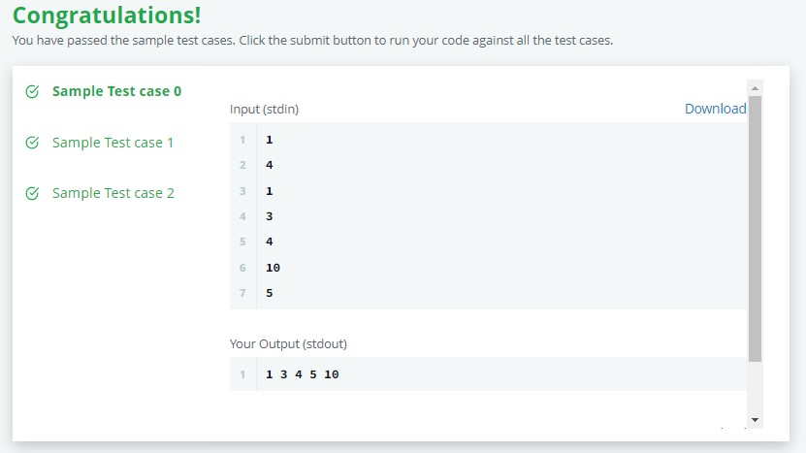

**Learning outcomes (What I have learnt) –**

**1.** We learned the concepts of implementing Linked List .

1. Here we learned how to insert a node in doubly linked List.
2. We learned how to merge linked lists and find the merge point.